Boot Coriolis OS

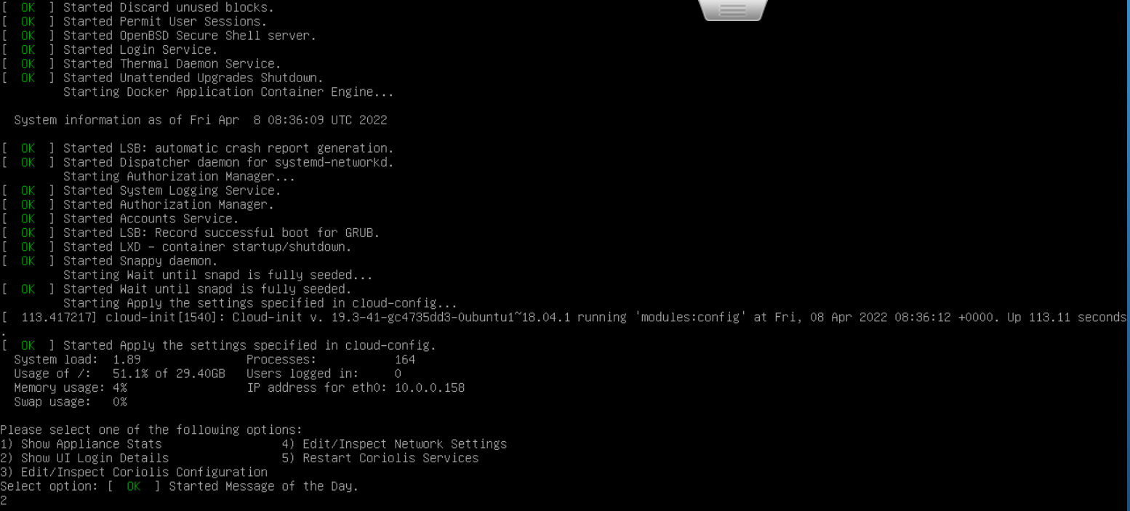

select option 2

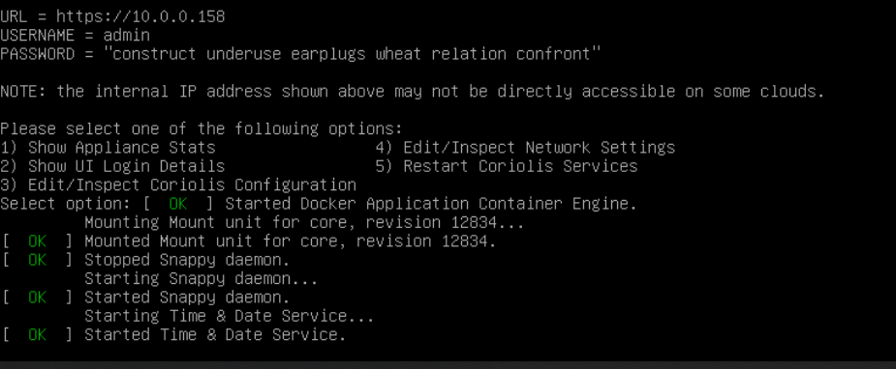

Run the URL (10.0.0.158) on your browser

Fill the user and password from the boot

For the first time the user is **admin**

And the Password is **construct underuse earplugs wheat relation confront**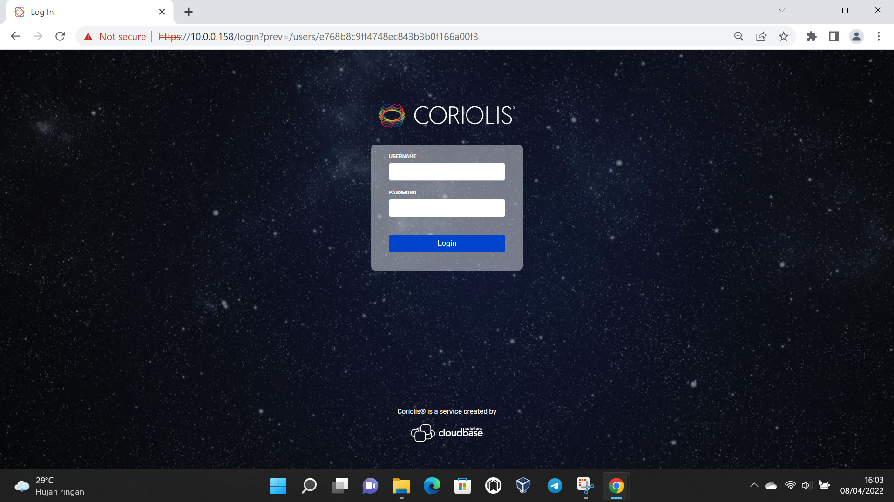

**This is the Coriolis GUI (after login)**

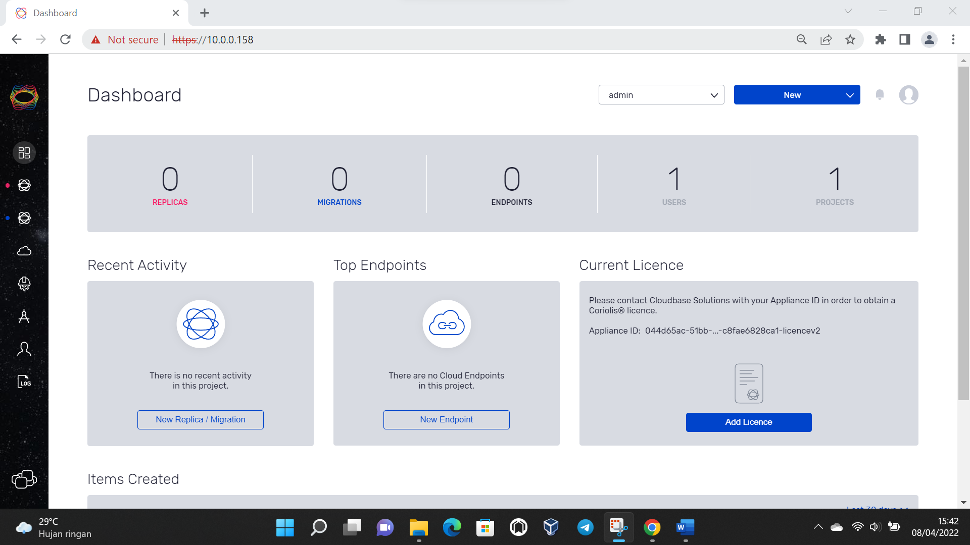

Add new endpoint:

New -> Endpoint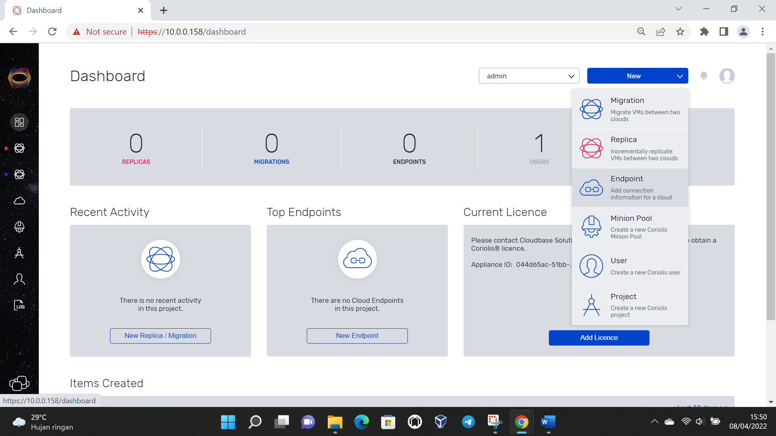

Choose your cloud

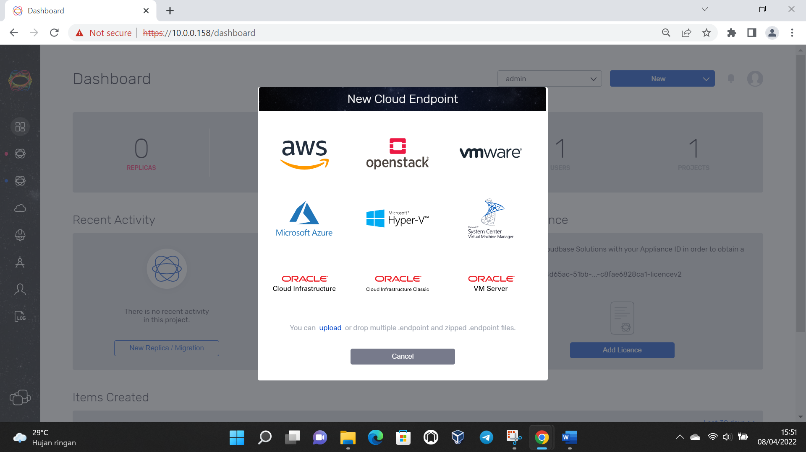

Fill with your machine address and configuration

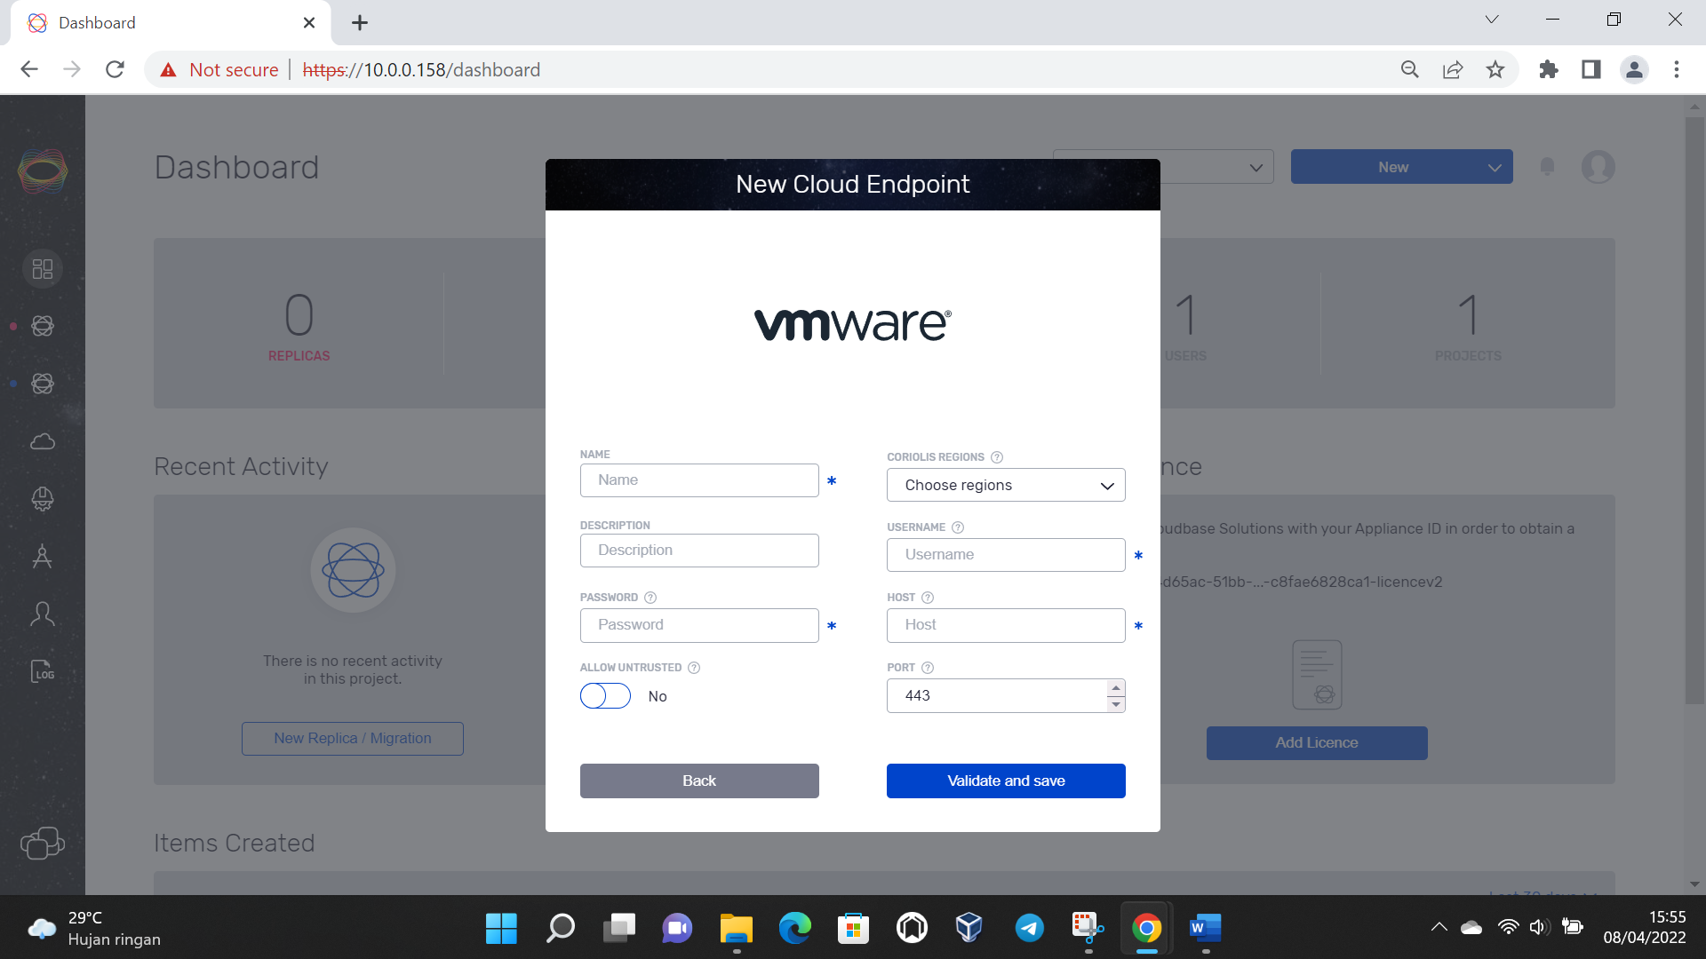

Then validate and save

Same like make VMware endpoint, you can set end point for openstack

With end-point menu on the left side we can see the cloud end point

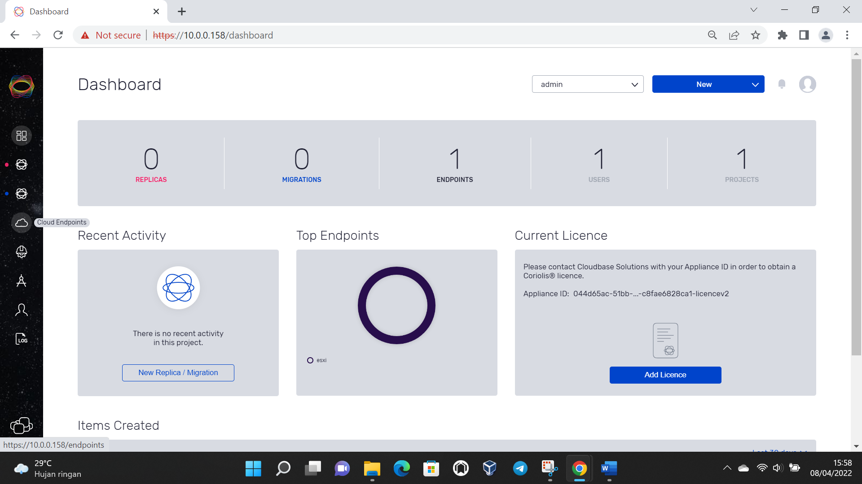

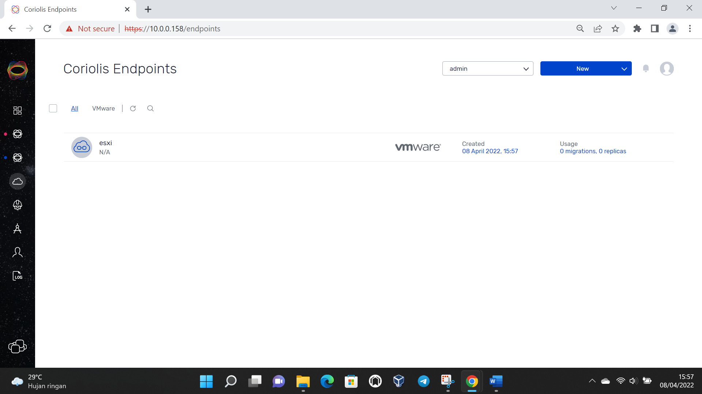

Also you can add and config migration job, replicas job, worker(minion), and user in menu new

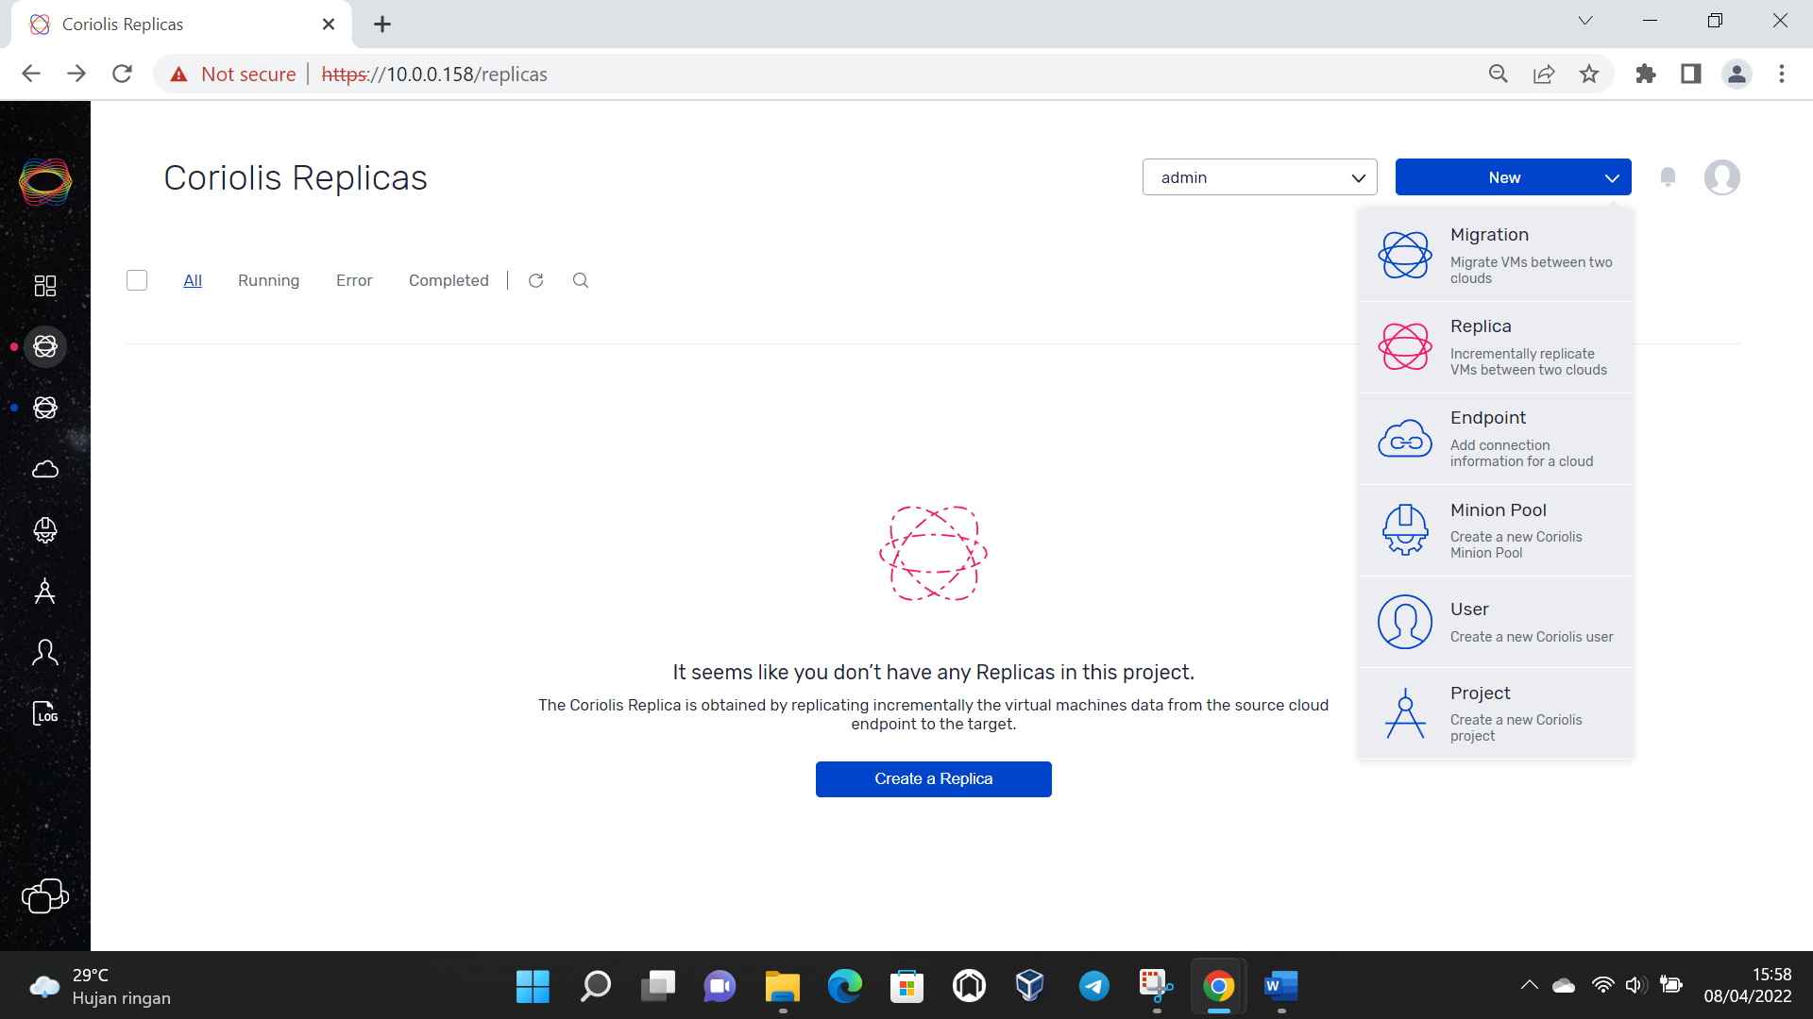

Replicas:

Choose the source platform and endpoint will use for migration

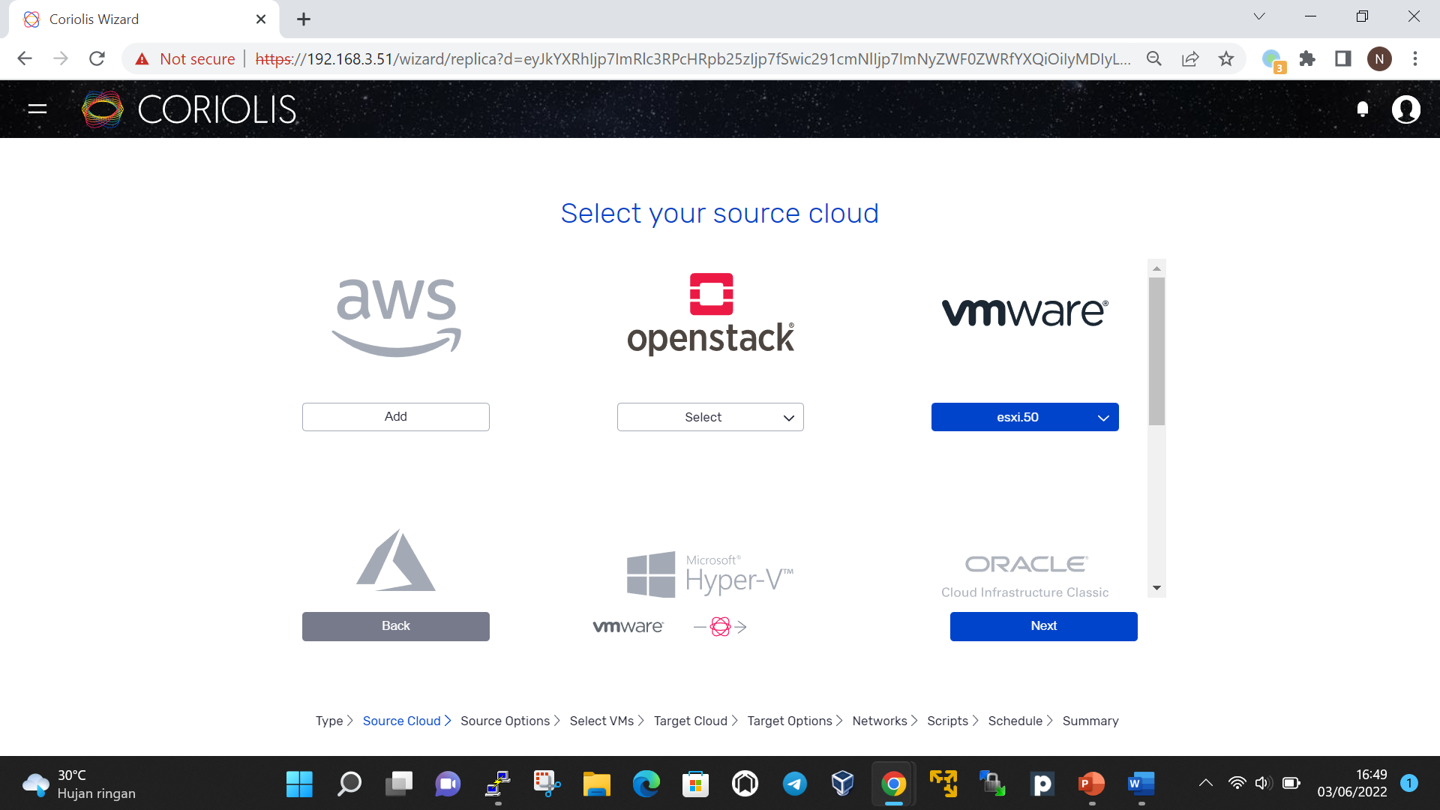

Select the instance

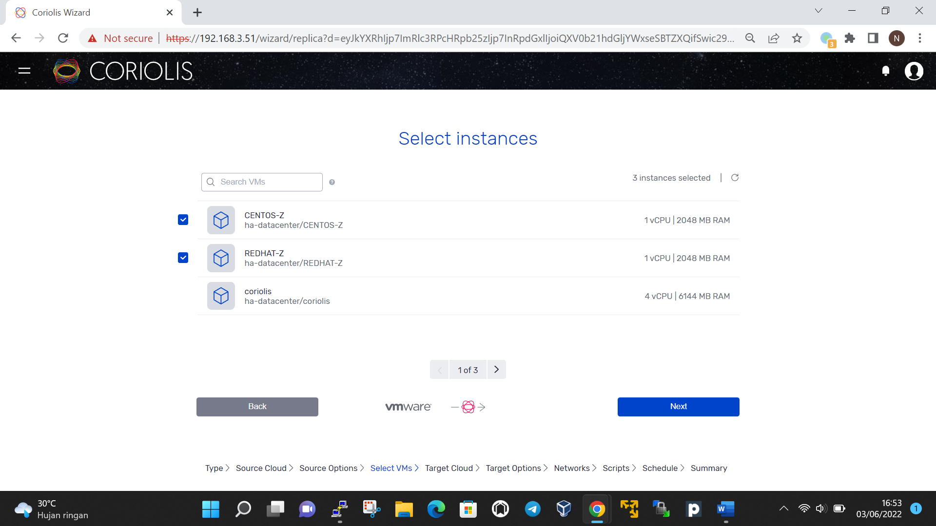

Choose target endpoint

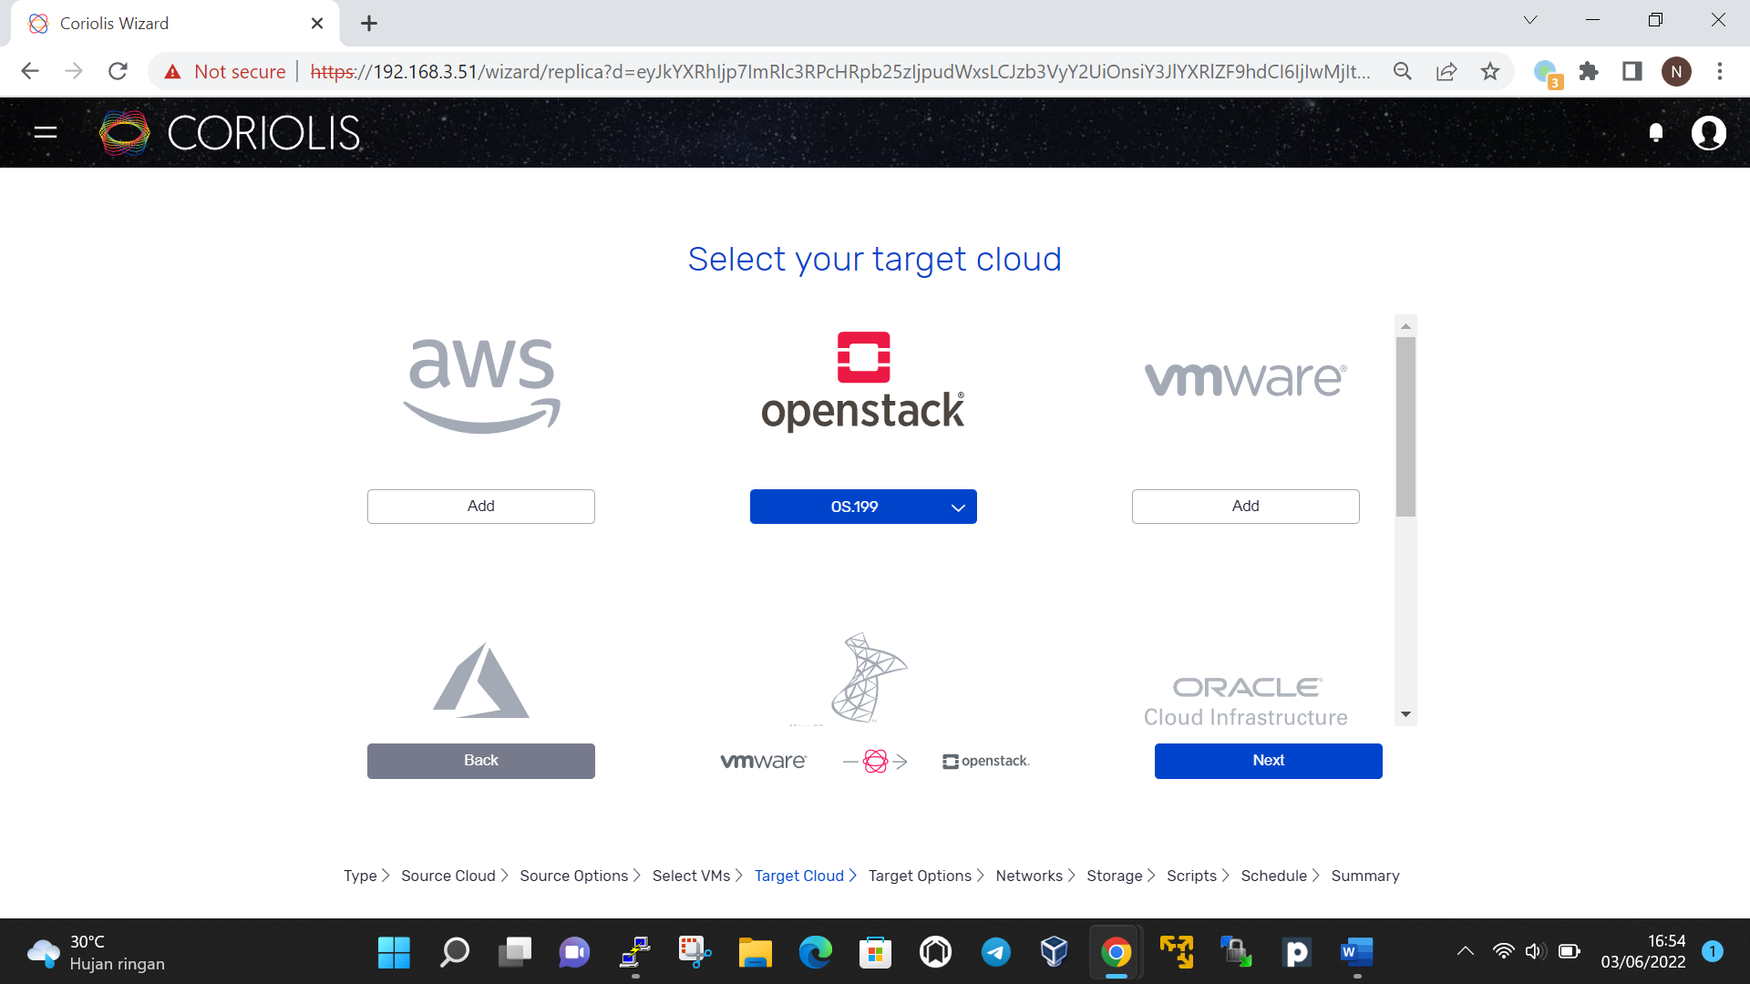

Setup the target and worker configuration

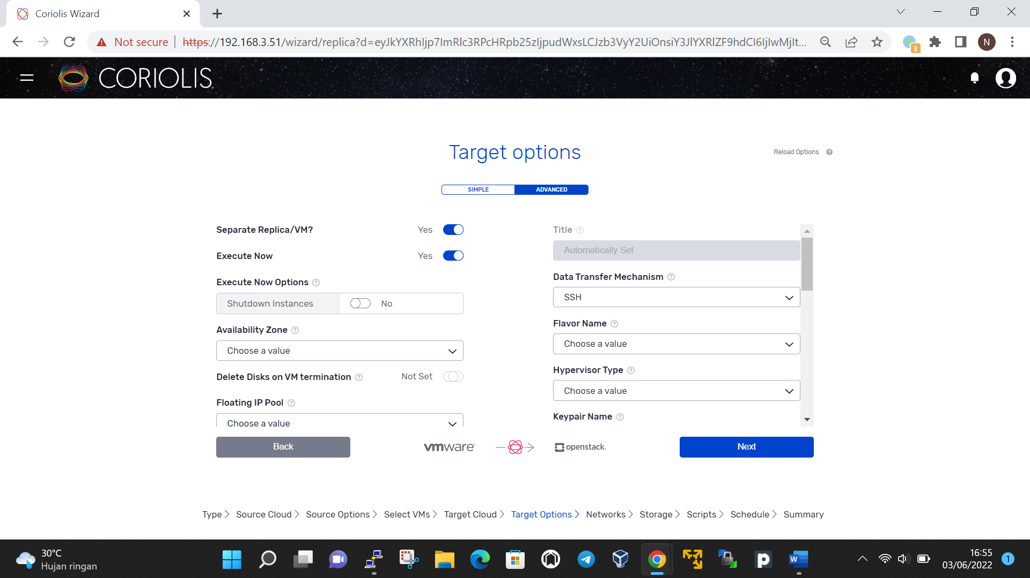

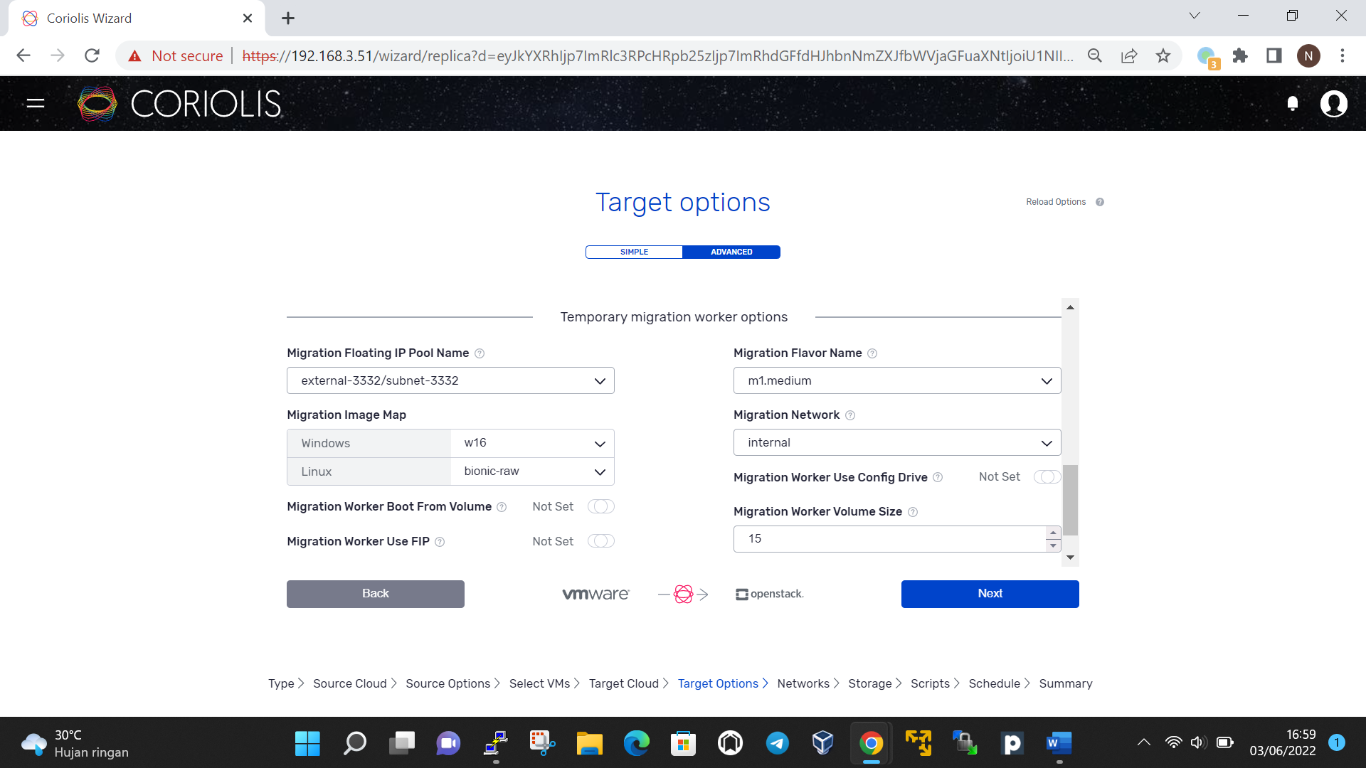

Then choose network will communicate between source cloud, worker, and target cloud

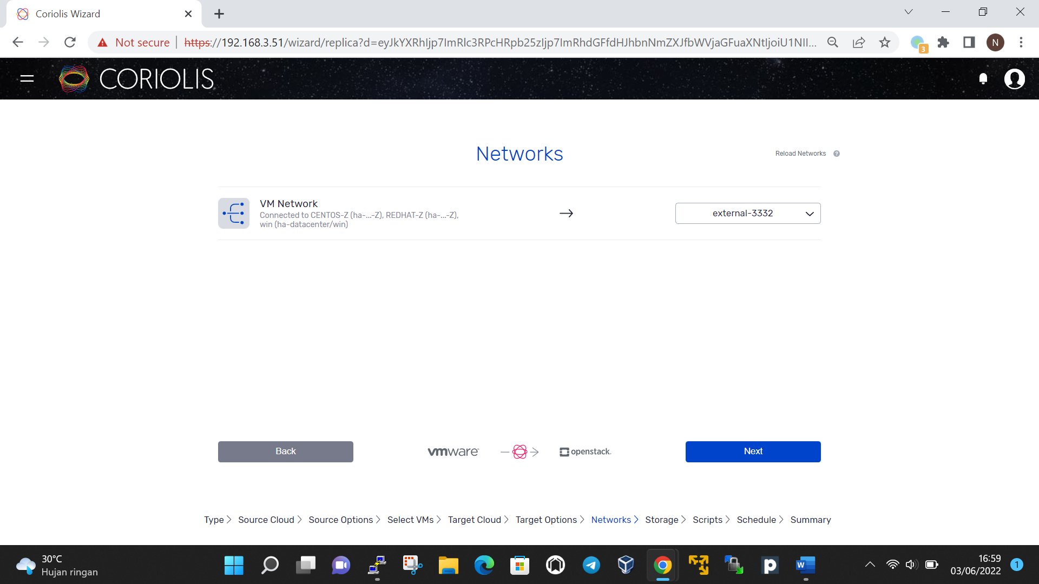

Then config the storage mapping

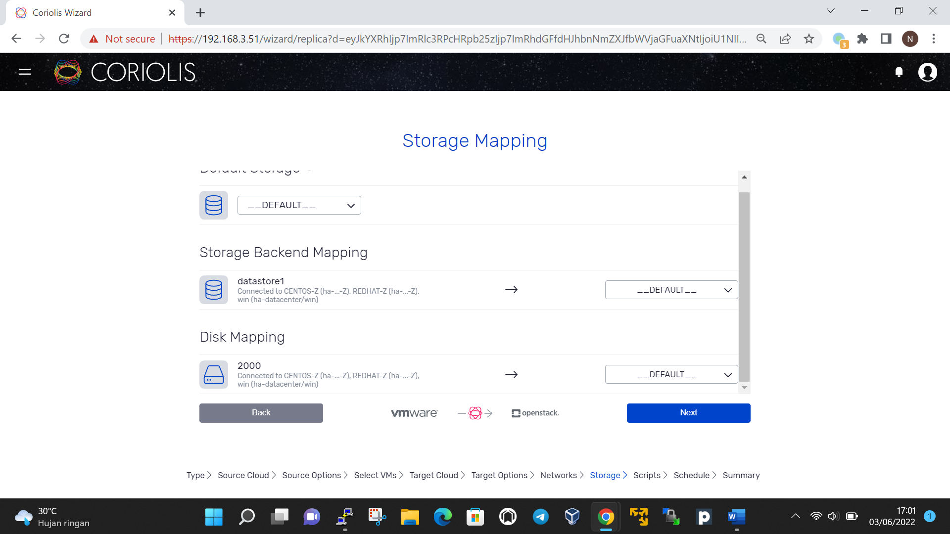

Also if need manual script, you can input the script on next step

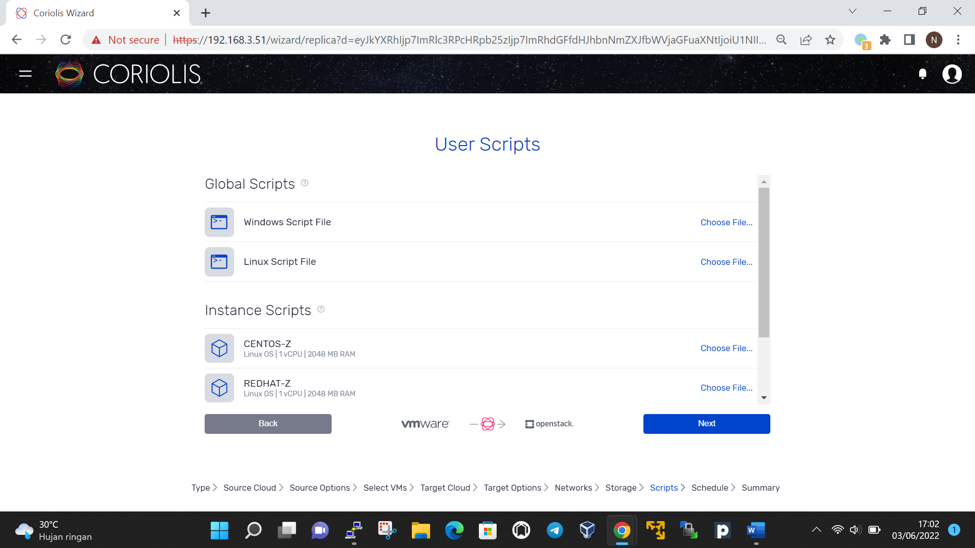

Next step is schedule the execution time and date

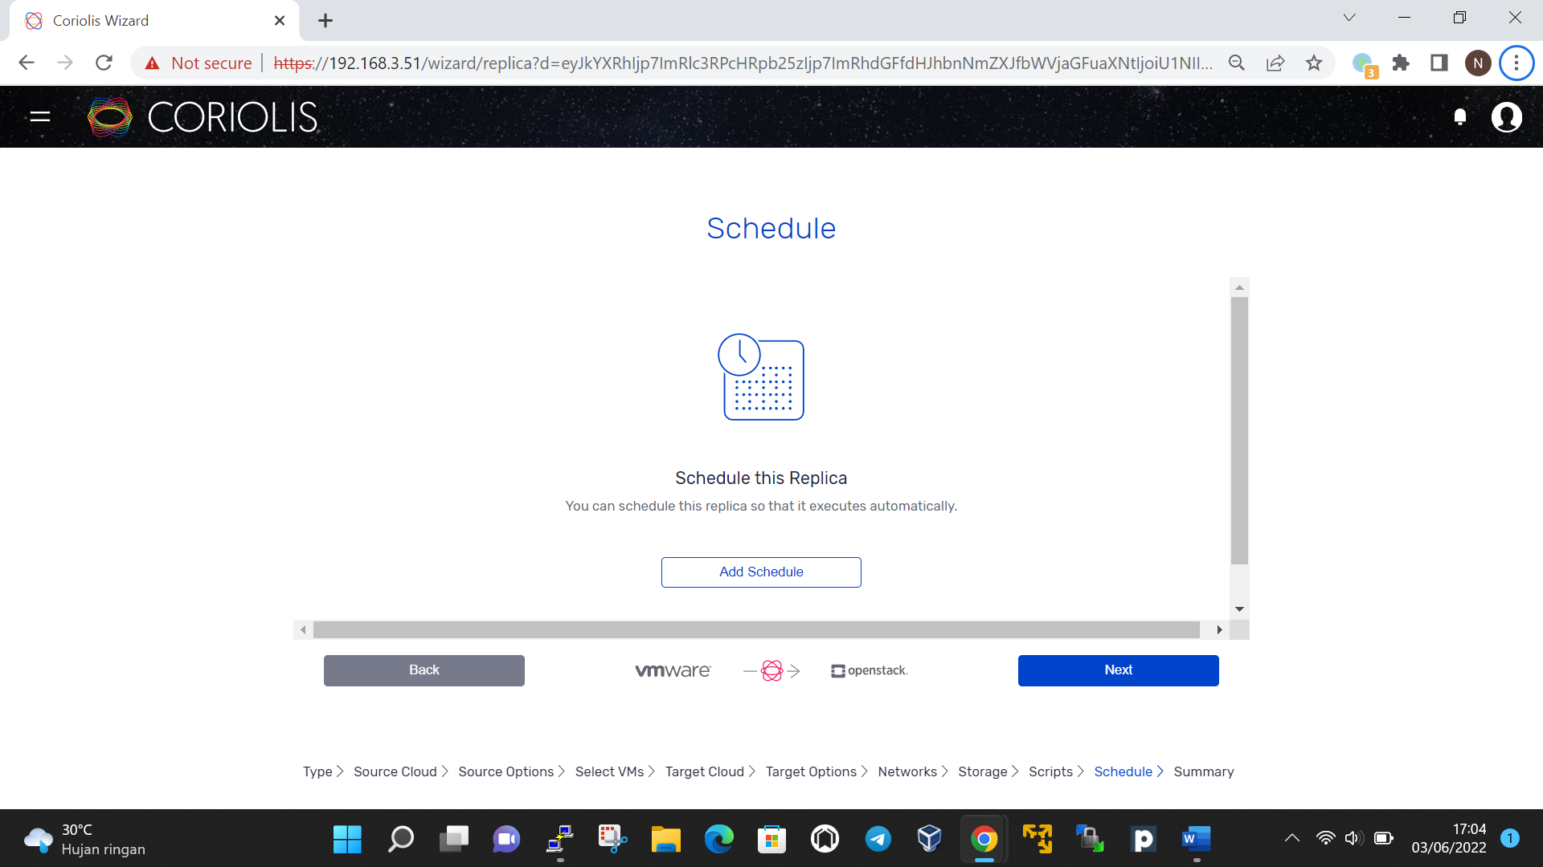

Sumary

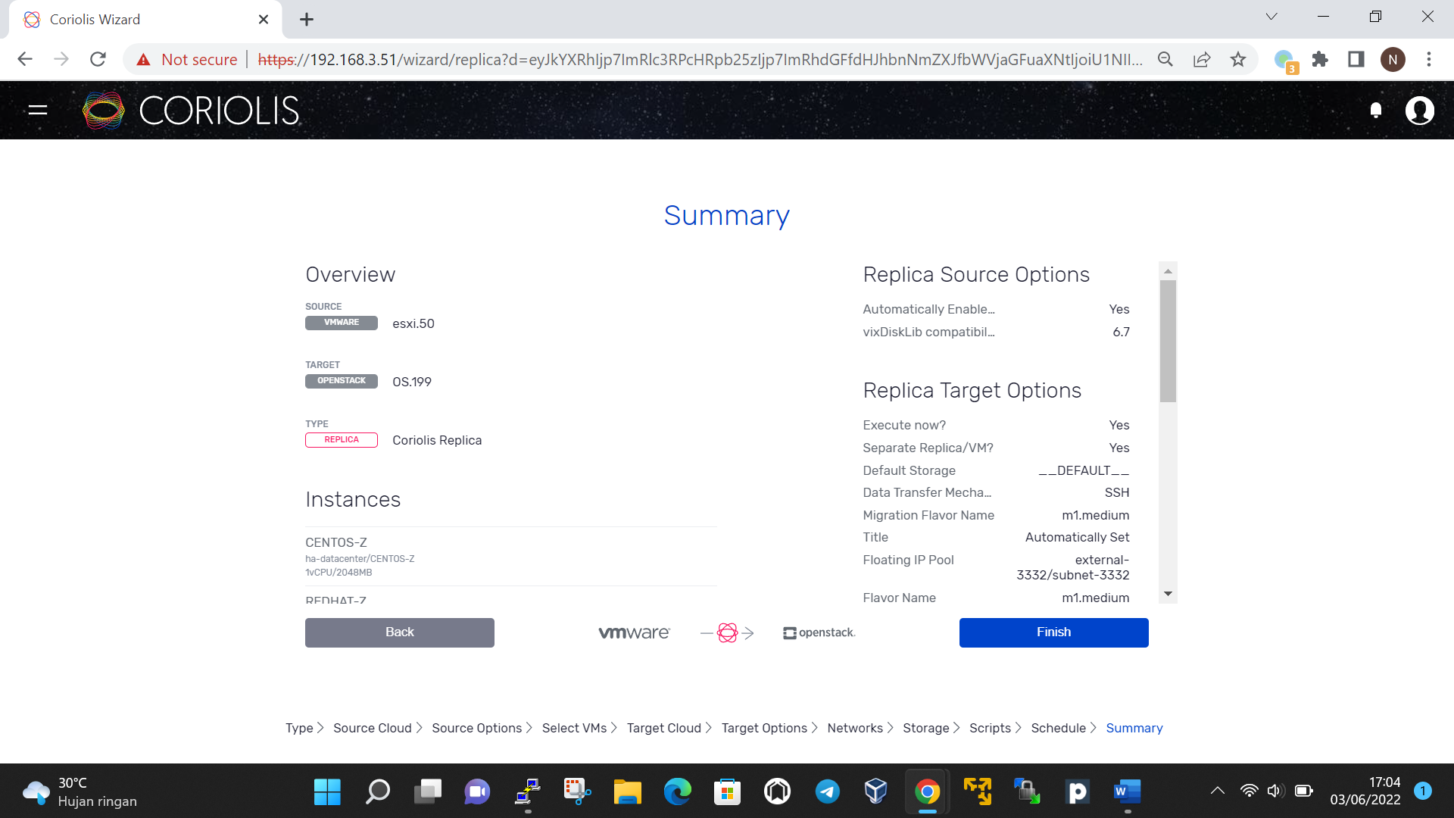

Then finish

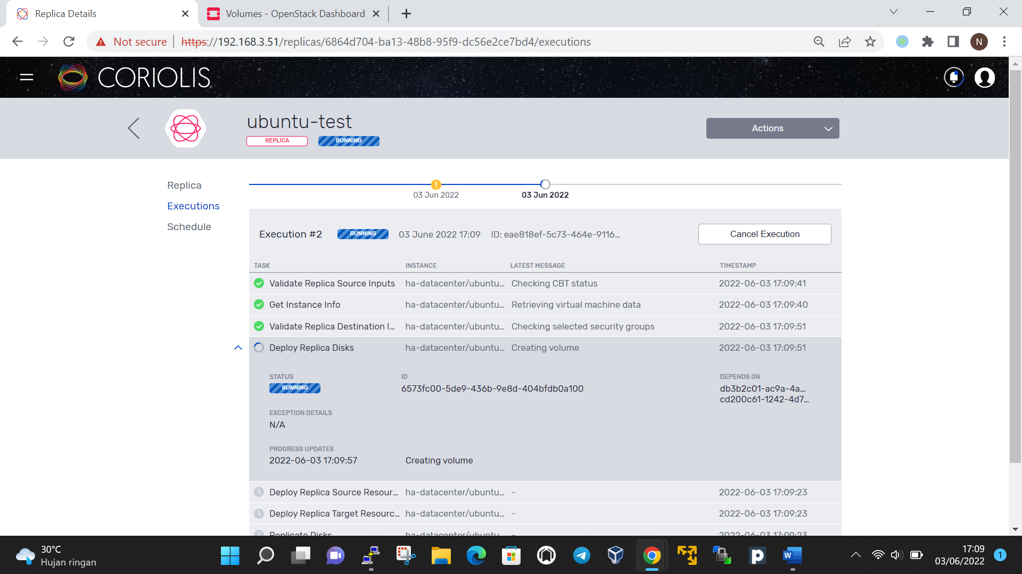

When replicas finish move to openstack volume

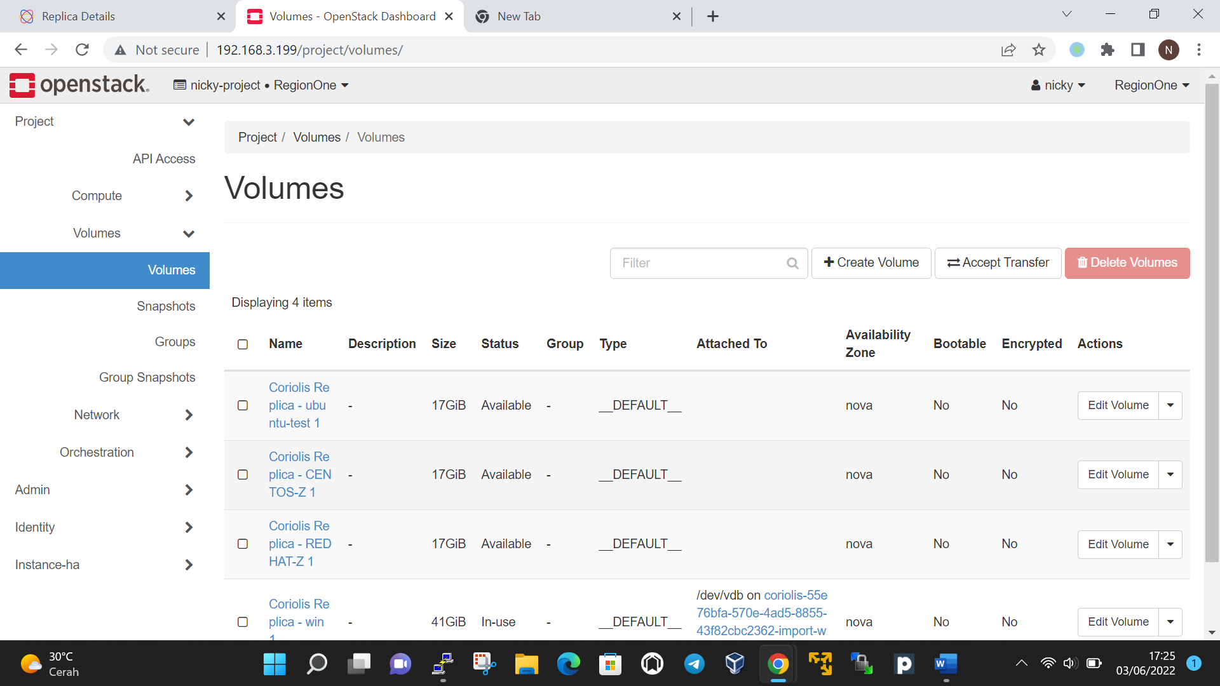

Set volume bootable so volume can use as source to make instance

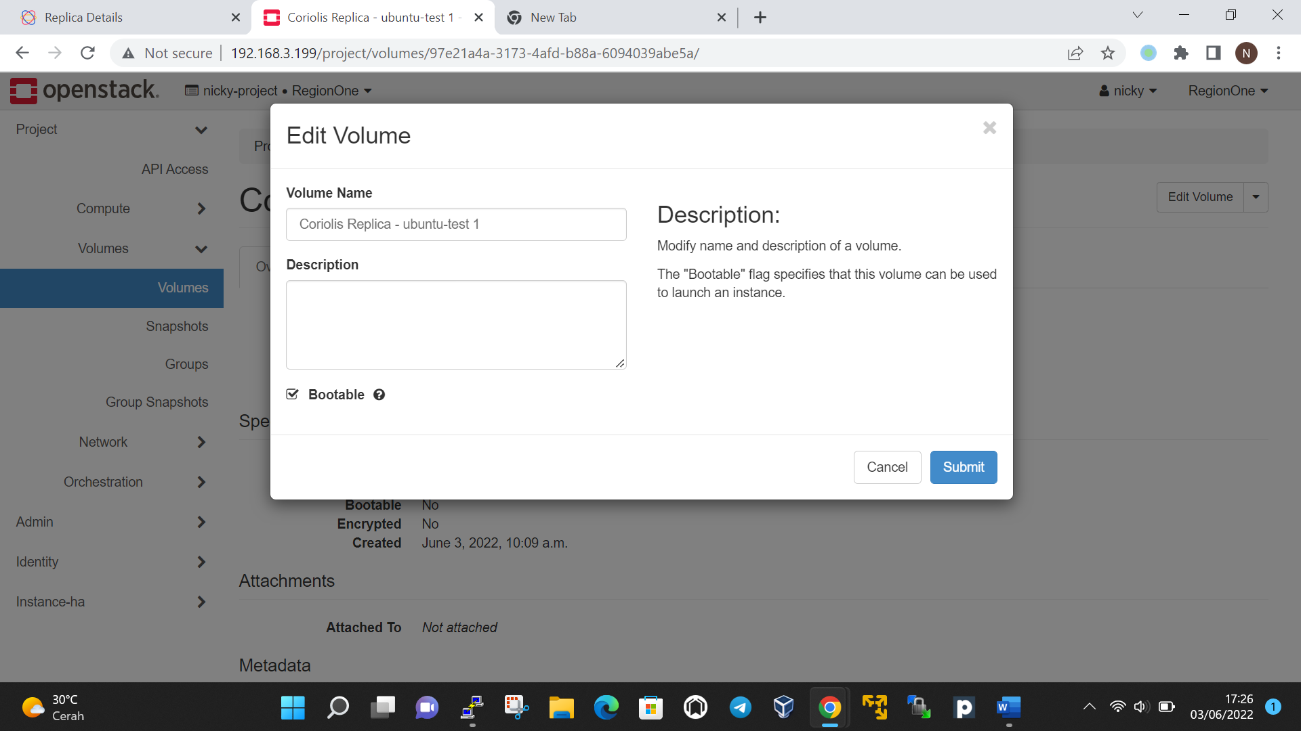

Launch instance with the volume

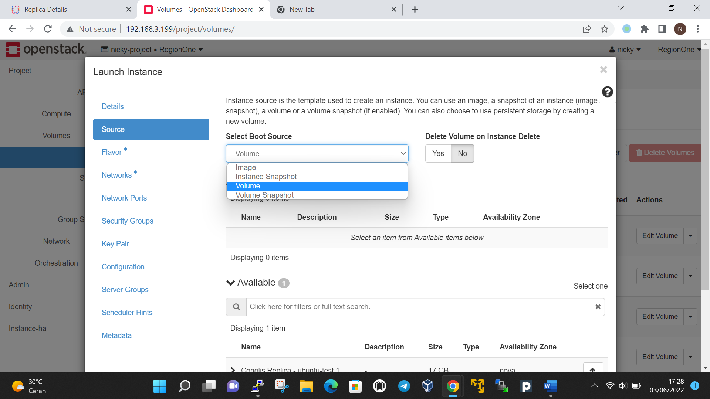

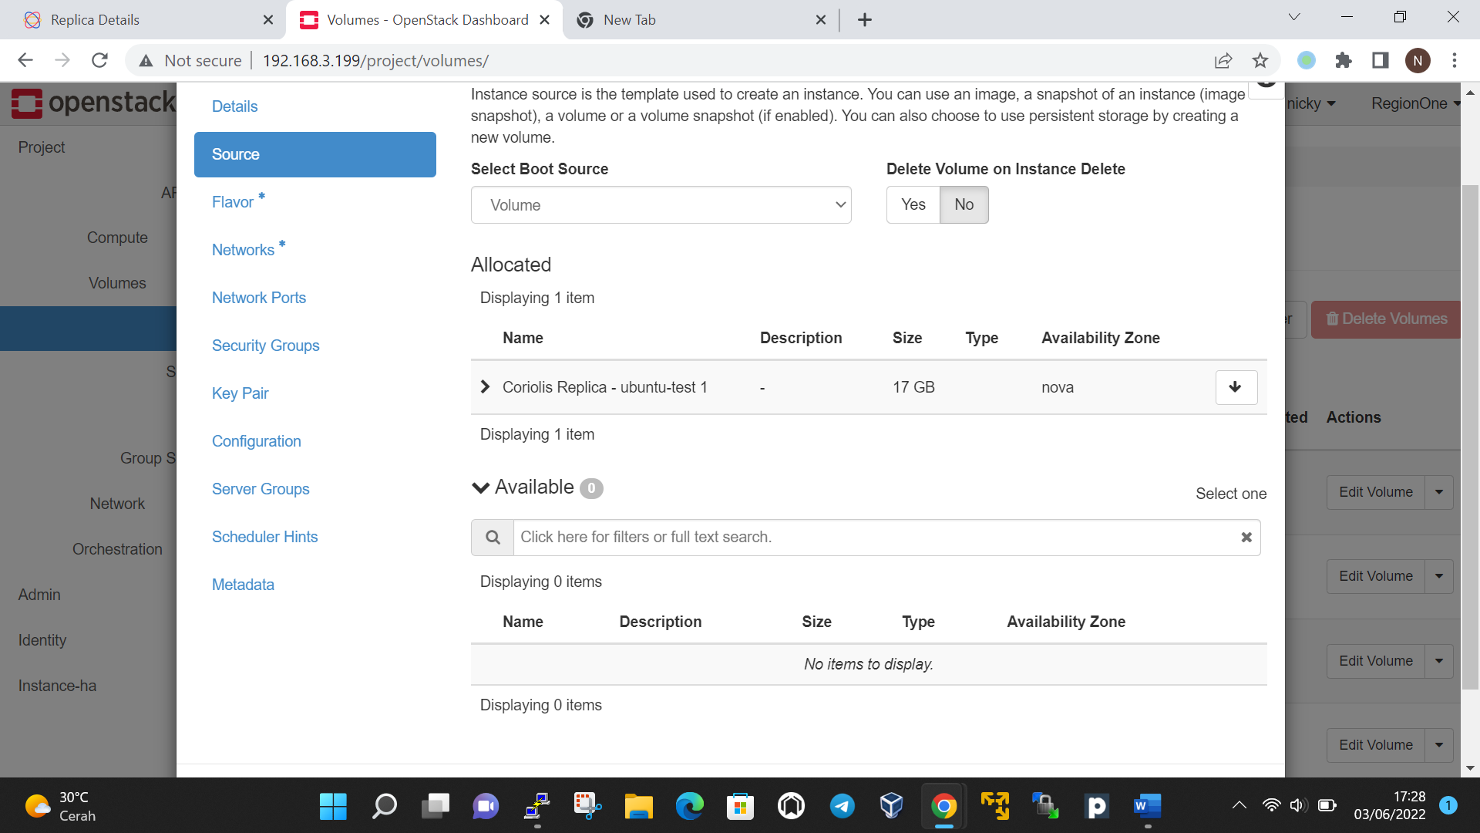

Manual:   
install ovftools

Buka command center

Run:

.\ovftool.exe vi://ip_source/VMname loc_destination

Convert ke RAW with qemu emulator :

C:\qemu-img\qemu-img.exe convert -O raw source.vmdk output.raw

Upload to openstack

dracut –regenerate-all --force